Develop from Design

Table of Contents

What are Mocks?

Strategies

More Style Options and Properties

Gradients

Transitions

CSS Resets

# What are Mocks?

Often a web developer is given a design, or a mock up, of the webpage by a graphic or web designer. The developer’s job is to make that design a webpage, while being as close as possible to the original design.

# Strategies

Usually fonts, colours, and images are provided to aid in this task. But not all the time. [Colour pickers](https://imagecolorpicker.com/) can be used to determine exactly what colours are being used in the design. A photo editor is also a valuable tool to have. While it can be robust, it can help if other photo manipulation has to be done.

Each developer works differently, but one thing you will need is a plan. Most developers will use pencil and paper (or modern digital tools) to draw out the layout of a webpage. After that, some developers will write the HTML first, then the CSS. Others will write the HTML and CSS simultaneously.

Practice and experience will tell you which path works best for you. But always have a plan!

# More Style Options and Properties

CSS has become a very powerful tool when creating visually appealing web pages. A word of caution: some options are very new and not completely supported by all browsers, or have varying levels of support. As such, [vendor prefixes](https://www.lifewire.com/css-vendor-prefixes-3466867) should be used if necessary.

### Gradients

CSS gradients let you display smooth transitions between two or more specified colors. You can use linear or radial type gradients.

Here’s an example of a linear gradient from left to right:

### 

Gradients can be a great way of improving the look of your pages. [Here’s an article](https://developer.mozilla.org/en-US/docs/Web/CSS/CSS_Images/Using_CSS_gradients) that covers many of the options you have when creating your own gradients.

### Transitions

CSS transitions allow you to change property values smoothly, over a given duration. A simple transition that we’ve already seen is using the :hover pseudo-class to change a style when the mouse hovers over the tag. However, we can make this change appear to happen more smoothly.

Consider this CSS:

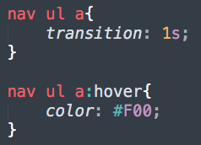

The :hover is still being used, but by adding a transition property with a value of 1s (1 second) on the <a> tag, the transition will take place over 1 second, rather than instantaneously.

There’s much more you can do with transitions. [Here’s a great article](https://css-tricks.com/almanac/properties/t/transition/) that can give you even more control and ideas for CSS transitions.

### CSS Resets

In order to deal with the inconsistencies between browser default stylesheets, **CSS resets** were born. A CSS reset is a set of styles applied to a page before any other custom styles, with the purpose of creating a more standardised base between browsers.

Here’s an example of what the top of a CSS file would look like with a reset in place:

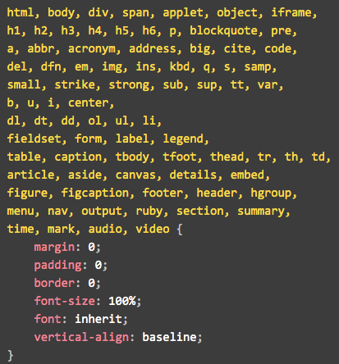

Granted, this is an extreme example. All tags here having properties that have different default values depending on the browser are baselined. More common is creating a reset that only covers the tags that the page uses.